|  |  |  |  |  |  |  |  |  |  |  |  |  |  |  |  |  |  |  |  |  |  |  |
| --- | --- | --- | --- | --- | --- | --- | --- | --- | --- | --- | --- | --- | --- | --- | --- | --- | --- | --- | --- | --- | --- | --- |
| **mini Project - 1**     |  |  | | --- | --- | | **Student Name/ID Number:** | **Tamim Hossain** | | **Unit Number and Title:** | ACWD Module 4 – Database Design & Implementation | | **Academic Year:** | **2022** | | **Unit Assessor:** | **Arvinder Kaur** | | **Project Title:** | Database Design for Community Portal | | **Issue Date:** | **24/07/2022** | | **Submission Date:** | **27/07/2022** | | **Internal Verifier Name:** |  | | **Date:** | **27/07/2022** |              |  | | --- | | **Learner declaration** | |  | | I certify that the work submitted for this assignment is my own and research sources are fully acknowledged.      Student signature:  Date: 27/07/2022 | | |
| |  | | --- | | **Purpose of this project** | | **Purpose of this project**  To demonstrate your capabilities in the following areas:  • Design a Database for Community Portal | | **Submission Format** | | 1. Description of Entities in the database 2. Screen capture of the ER Diagram 3. Screen capture of Data 4. Screen capture of Normalized Database Design 5. Documentation of Relationships | | **Project Brief & Guidance** | | **Scenario:**    **Refer to the Project Scenario for the Module Project**  You have been approached by ‘ABC Jobs Pte Ltd’ as a website developer to develop a community portal for Software Developers. The project will be carried over through Module 3, Module 4, Module 5 and Capstone project. For this module the scope is to Design, Develop, Implement & Document Apache Struts Framework Website.  The Scope of the Project is to design a Community Portal Similar to Linkedin.com. Users will be able to register in the portal using the Registration Page. Users of the portal can search for other users using various parameters such as First Name, Last Name, Company Name, City & Country. Users will be able to view the Public Profile of users after searching them. The portal allow users to login, request for forgotten password and Update their profile information    The scope of the mini project is to design the database.    **The overview of the project is as below**  There are 2 types of users in this Community portal. They are   1. Software Programmer 2. Administrator     **Software Programmer should be able to perform following functions in the portal** | |

|  |  |
| --- | --- |
| |  | | --- | | 1. Allow the programmers to register in the portal, show a thank you page & send a registration confirmation email. 2. Search & Find Other Programmers after login and view their profile. 3. Provide Login Page 4. Provide password retrieval functionality. 5. Update their Profile after logging in.     Following Functionality is part of Database Design & Will be enhanced as features as required in the Capstone Project, Depending on time availability.     1. Send Messages to Each Other on the Portal 2. Create Threads & Post Replies to a Thread 3. Post Job Opportunities in the Portal     **Administrator should be able to perform following functions in the portal**   1. Administer user data. 2. Send bulk email inviting programmers to register on the community portal     **The portal consist of the following Key pages (For Reference)**   1. Community Portal Home Page 2. Registration Page 3. Registration Confirmation Page 4. Update Profile Page 5. Search Users Page 6. List Search Results 7. Public Profile Page 8. Registration Confirmation Email 9. Login Page 10. Forget Password Page 11. Design the Forget Password Confirmation Page     Following Functionality is part of Database Design and will not be part of development & Will be enhanced as features are required in the Capstone Project, Depending on time availability.   1. Send Messages 2. Read Messages 3. Post in Message Board 4. List Message Board 5. Read A Thread 6. Post Job Opportunities 7. List Job Opportunities & Responses     **The scope of this assignment**  The scope is to design the community portal database.   1. Identify the Entities in the Community Portal Database 2. Create ER Diagram for the Community Portal Database | |
| |  | | --- | | 1. **Create Sample data for all tables in the community portal (At least 3 tables)** 2. **Normalize the complete database to 3rd normal form (Provide screen capture of the normalization done)** 3. **Identify the relationships in tables & document them** | |

1. **Identify the Entities in the Community Portal Database**

|  |  |  |
| --- | --- | --- |
| **Name** | **Description** | **Column** |
| **Log in Homepage** | **The homepage log-in form is just for making the web user friendly and easy rotating Which is also a way to enter web with quick excess..** | * User_Id * User name * Password |
| **Registration** | **To enrol any website need some information about user for user benefit and security of website.** | * User_Id * User_Name * User_email * User_password * User_Retype password. |
| **Log In** | **To enter in deep of website to use that an user should meet up some condition .Without this he can not enter the job portal.** | * Log In_Id * Email * password |
| **Profile** | **In website an user interested to see his information.**  **In profile website give him this chance to his information .According to this information he can also chance his information.** | * **Profile_ID** * **Work links** * **Skills** * **User id** * **Name** * **Email** * **Phone** * **Profession** |
| **Update Profile** | **User Just have to click on view profile or user avatar there will be various option offers in order to change the avatar and the user information user can use this update profile option.** | * **Update profile_id** * **Change photo** * **Name** * **Email** * **Phone** * **profession** |
| **Jobs** | **A job searching website basically for job search .So ,there have many information about job .They may service may job offer ,details etc.** | * **Jobs_Id** * **Company name** * **Last date of Application** * **Job position.** * **Salary** |
| **Company** | **Generally, in community job portal company post their job by software programmer or their employee.**  **So, it is clearly mention in the job portal in definite job which company post it or this job owner which company .In job portal store the database of their company.** | * **Company_ID** * **Company Name** * **Address** * **Location** * **Website link** * **Contact** |
| **Messages** | **Allow members to send direct messages to start a private conversation with people, The user want to connect. Direct messages are supported in all ...** | * **Message_ID** * **Texts** * **Text receiver** * **Text sender** * **Time** * **Sent** |
| **Bulk Email** | **Bulk email is the act of sending one email campaign to a large group at once. Marketing messages, newsletters, updates, coupons, and invitations typically comprise bulk emails. Synonymous with mass email or email blasts, bulk emails focus on sending one central message to a large group of subscribers.** | * **Bulk Email_ID** * **Bulk Email** * **Bulk Email Type** |
| **Registration form** | **.After successfully registering with user name ,Email and password User Will be redirected to a Registration form though bulk mail Where user needed to input their Personal information** | * **Registration form_Id** * **First name** * **Last Name** * **Birth day** * **Gender** * **Phone** * **Country** * **City** |
| **Users** | **A user is a person who utilizes a computer · A user often has a user account and is identified to the system by a username (or user name)** | * **User_ID** * **User Name** * **User Email** |
| **Admin** | **An Administrator provides office support to either an individual or team and is vital for the smooth-running of a business** | * **Admin_ID** * **Admin Name** * **Admin Email** * **Admin Pass** |
| **Registration** | **Primary step of registration is to set up own username, Email, Password and confirm the password.** | * **Registration_ID** * **User Name** * **Email** * **Password** * **Confirm Password** |

1. **Create ER Diagram for the Community Portal Database**

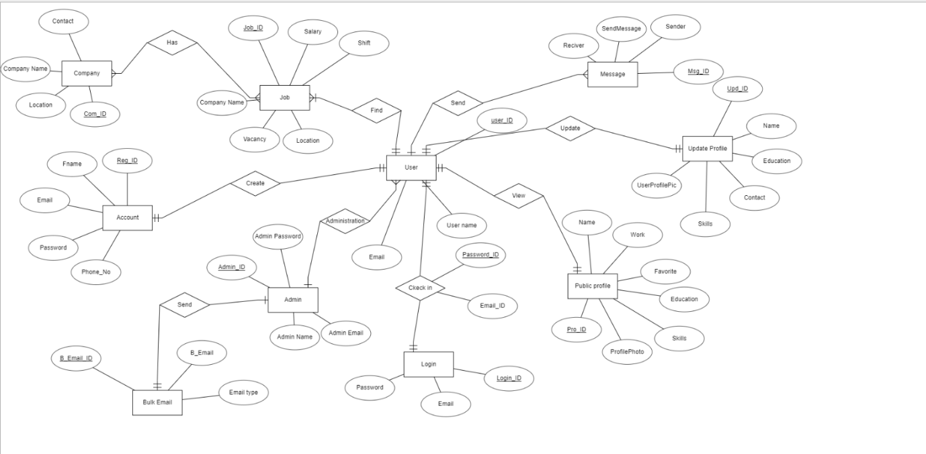

1. **Create Sample data for all tables in the community portal (At least 3 tables)**

**Registration table**

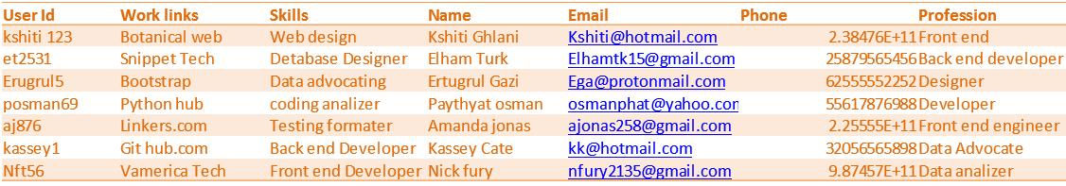**Profile table**

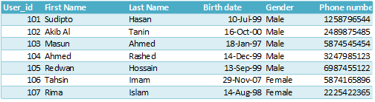

**Jobs table**

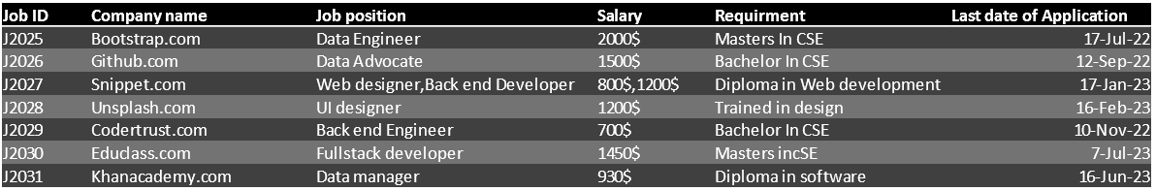

1. **Normalize the complete database to 3rd normal form (Provide screen capture of the normalization done)**

**Jobs**

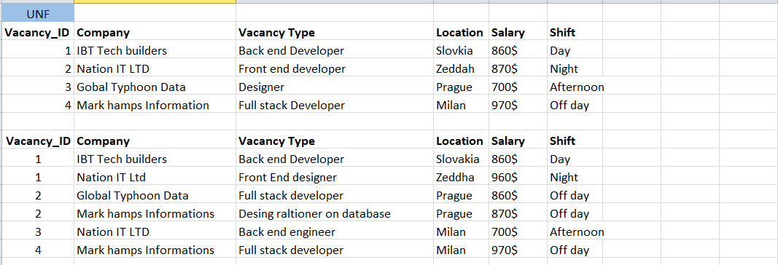

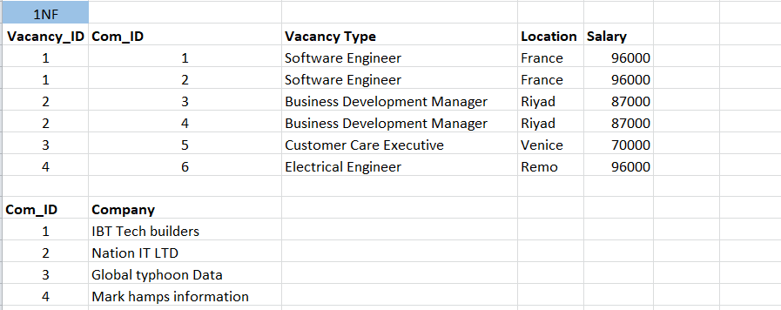

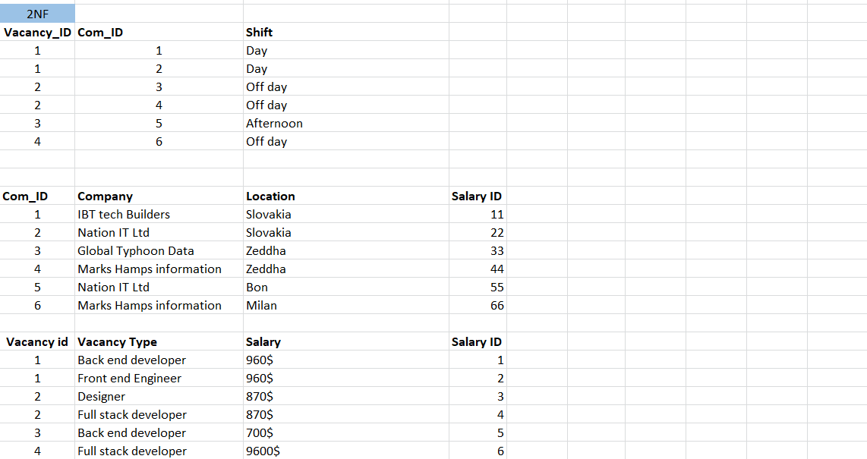

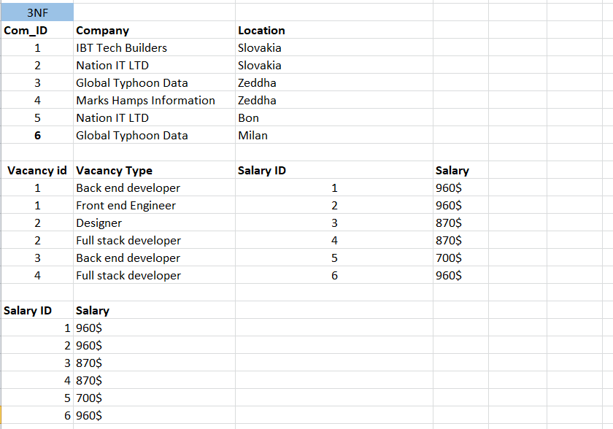

**User Profile**

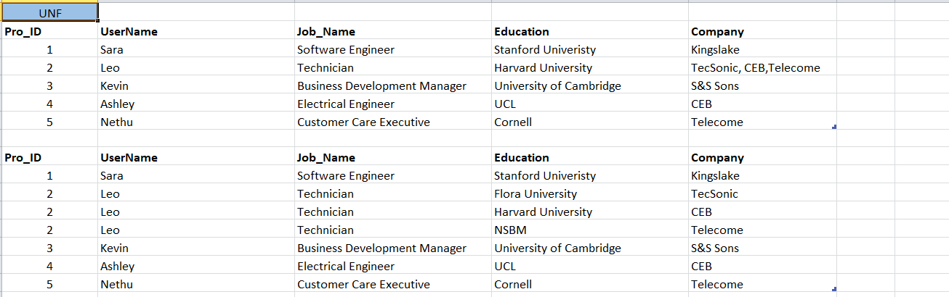

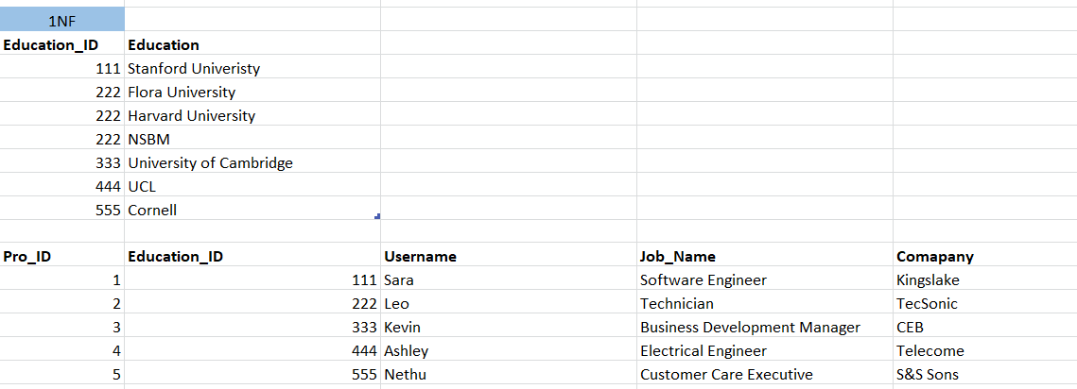

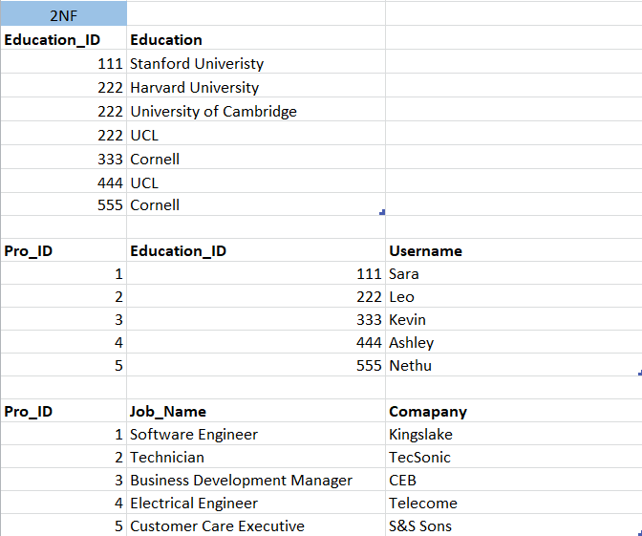

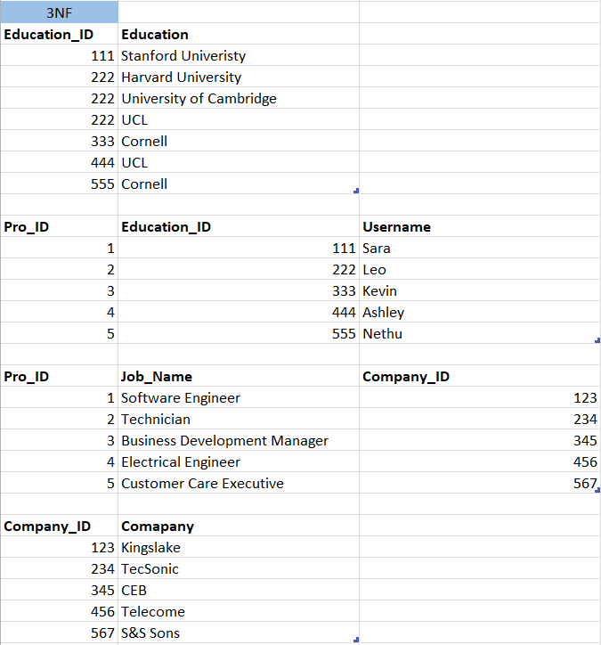

**Registration**

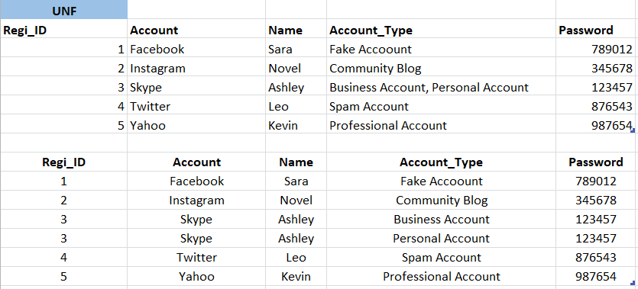

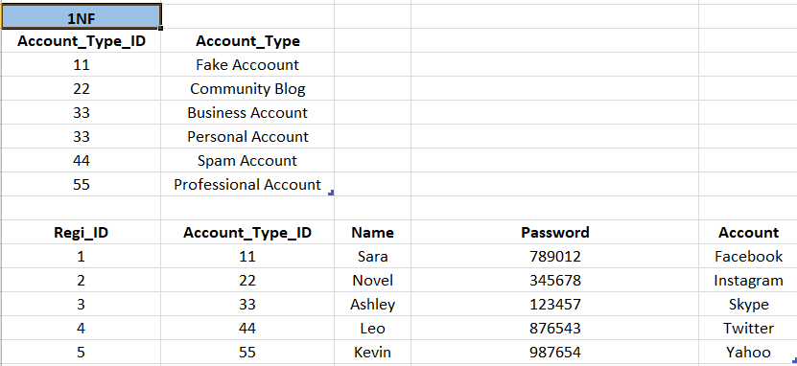

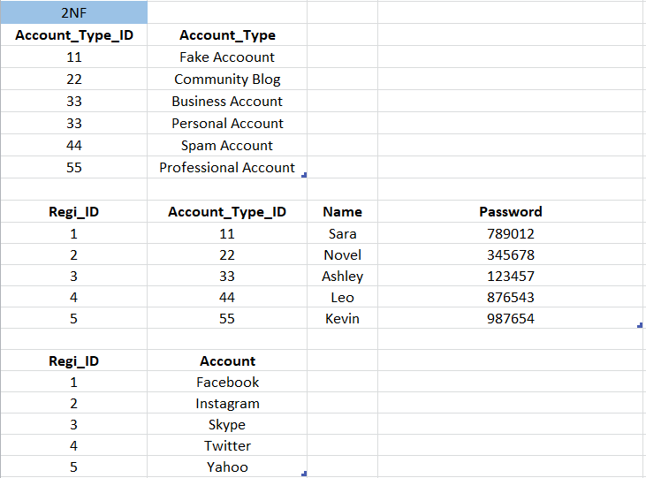

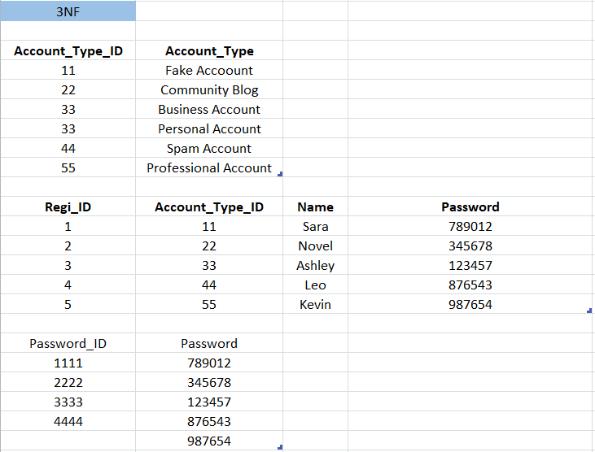

**e. Identify the relationships in tables & document them**

